Chapter 1
Session 1
Introduction
Biogeography is a branch of geography that studies the past and present distribution of the world's life (animal and plant species) and is usually considered to be a part of physical geography. Biogeography often relates to the examination (study) of the physical environment and how it affected species and shaped their distribution across the world.
As such (as well), biogeography also includes the study of the world's biomes and taxonomy (classification) and has strong ties (relations) to biology, ecology, evolution studies, climatology, and soil science as (also) they relate to animal populations and the factors that allow them to flourish in particular regions of the globe.
Biome is the largest geographic biotic unit, a major community of plants and animals with similar life forms and environmental conditions. such as grasslands or coniferous forest or temperate deciduous forest.
The field of biogeography can further be broken down into specific studies related to animal populations include historical biogeography, ecological biogeography, and conservation biogeography and include both phytogeography (the past and present distribution of plants) and zoogeography (the past and present distribution of animal species).

History of Biogeography
The study of biogeography gained popularity with the work of Alfred Wallace in the mid-to-late 19th Century. Alfred Wallace, originally from England, was a naturalist, explorer, geographer, anthropologist, and biologist who first extensively studied the Amazon River and then the Malay islands Archipelago (the islands located between the mainland of Southeast Asia and Australia).
During his time in the Malay Archipelago, Wallace examined the flora and fauna and came up with (proposed; discovered; suggested) the Wallace Line (a line that divides the distribution of animals in Indonesia into different regions) according to the climates and conditions of those regions and their inhabitants' proximity (affinity) to Asian and Australian wildlife. Those closer to Asia were said to be more related to Asian animals while those close to Australia were more related to the Australian animals. Because of his extensive early researchs, Wallace is often called the "Father of Biogeography."

Historical Biography
Today, biogeography is broken into three main fields of study: historical biogeography, ecological biogeography, and conservation biogeography. Each field, however, looks at phytogeography (the past and present distribution of plants) and zoogeography (the past and present distribution of animals).
Historical biogeography is called paleobiogeography and studies the past distributions of species. It looks at their evolutionary history and things like past climate change to determine why a certain species may have developed in a particular area.
For example, the historical approach would say there are more species in the tropics than at high latitudes because the tropics experienced less severe climate change during glacial periods which led to fewer extinctions (overthrow; ən-ghə-rãz) and more stable populations over time.
The branch of historical biogeography is called paleobiogeography

because it often includes paleogeographic ideas — most notably (specially, particularly) plate tectonics —. This type of research uses fossils (ã; ə) to show the movement of species across space via moving continental plates.
Space: here it means area or expanse (ǵos-tā-rəh; pāh-nəh).

Ecological Biogeography
Ecological biogeography looks at the current factors responsible for the distribution of plants and animals, and the most common fields of research within ecological biogeography are climatic equability, primary productivity, and habitat heterogeneity. Equality: homogeneity; equalization; hām-sã-ny
Climatic equability looks at the variation between daily and annual temperatures as it is harder to survive in areas with high variation between day and night and seasonal temperatures. Because of this, there are fewer species at high latitudes because more adaptations are needed to be able to survive there. In contrast, the tropics have a steadier climate with fewer variations in temperature. This means tropical plants do not need to spend their energy on being dormant (sleeping) and then regenerating their leaves or flowers, they don’t need a flowering season, and they do not need to adapt to extreme hot or cold conditions.
Conservation Biogeography
In recent years, scientists and nature enthusiasts have further expanded the field of biogeography to include conservation biogeography—the protection or restoration of nature and its flora and fauna—, whose devastation (destruction) is often caused by human interference in the natural cycle.
Scientists in the field of conservation biogeography, study ways in which humans can help restore the natural order (discipline) of plant and animal life in a region. Often times this includes reintegration of species into areas zoned (delineated) for commercial and residential use by establishing public parks and nature preserves at the edges of cities. Zoned: determined for a particular type of use or development.
nature preserves: an area where animals and plants are protected
-Biogeography is important as a branch of geography that investigates the natural habitats around the world. It (biogeography) is also essential in understanding why species are in their present locations and in the world's natural habitats.
Session 2
The Darwinian periods
• Four English scientists were responsible for revolutionizing (making fundamental changes) concerning with (regarding) the origin and distributions of species.
1-Charles Lyell initiated his publication of Principle of Geology in 1830. He pictured the physical world as a world gradually changing through the cons (disadvantages) of time, responding to predictable physical processes. pros and cons (advantage and disadvantages)
2- Charles Darwin set sail in 1831 on a five-year surveying voyage aboard (over; into) Beagle ship as a scientist companion for its captain, Robert Fitzroy. Beagle: spy, detective ()
• Darwin studied
-Geology,
-Native plants and animals,
-Indigenous peoples, and
-Domesticated animals during the journey in an attempt (trying to) to understand the order of life.

-During the voyage of the Beagle ship, Darwin was intrigued (fascinated) and perplexed (confused) by the patterns he observed, the fossils of the extinct beasts in Argentina, the presence of Seashells at high elevation in Andes, and the occurrence of unique forms of life on islands.

-The pattern of variability in the Equator, in which different species or races of tortoises and finches inhabit different islands, inspired (el-ham bakh-shi-dan) him to the idea that geographic isolation (retreat; ən-zə-vã) facilitates inherited changes within and between populations. inherited: ər-sy
On his return to England, Darwin developed his theory of evolution, invoking (citing, es-te-nad kar-dan) natural selection as the primary mechanism by which new forms of life created and are still creating today.
3-But, Alfred Russel Wallace, has been considered the father of zoogeography because he produced three massive works (1869, 1876, and 1880) that synthesize (combine) the basic concepts of zoogeography using the theory of natural selection.
4-A fourth great British contributor was Joseph Dalton Hooker, who was the world’s most ambitious plant collector. showing a strong desire to succeed
At the age of 22, he became a botanist on an expedition (əå-zãm) to the Antarctic region led by Sir James Clark Ross (the discoverer of the Magnetic North pole, Arctica).
Biogeography since the early 1960s
During this period, four major areas (domain; hov-zəh) of research have revitalized biogeography;
1. acceptance of plate tectonics,
2. development of new phylogenetic methods,
3. explorations of new ways of conducting research in ecological biogeography, and
4. investigations of the mechanisms limiting distributions.
Tectonics are the processes that control the structure and properties of the Earth's crust and its evolution through time.
Ridge: edge; trench: geological movement of tectonic plates
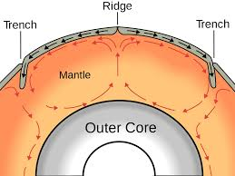

Earth's mantle: A mantle is a layer inside a planetary body bounded below by a core and above by a crust.

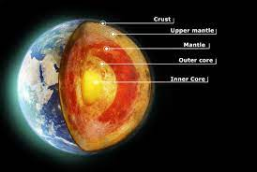

Plate tectonics: is the theory that Earth's outer shell is divided into large slabs (piece, slice) of solid rock (ə), called “plates,” that glide over Earth's mantle, the rocky inner layer above Earth's core.
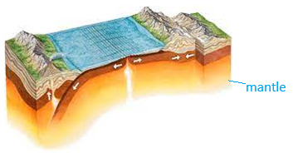

Continental drift: is the hypothesis that the Earth's continents have moved over geologic time relative to each other.
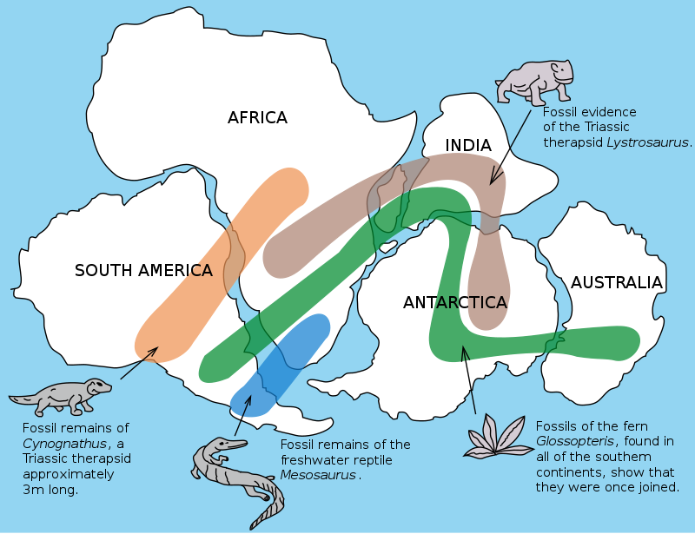
The therapsid gave rise to (caused to appear) mammals (Mammaliaformes) in .the Late Triassic, around 225 million years ago.
Fern: A fern is a member of a group of vascular plants (plants with xylem and phloem) that reproduce via spores and have neither flowers nor seeds. Indian subcontinent
gave rise:

Pangea, also spelled Pangaea, in early geologic time, a supercontinent that incorporated almost all the landmasses on Earth
Panthalassa, also known as the Panthalassic Ocean was the super ocean that surrounded the supercontinent Pangaea

Plate tectonics and continental drift, first introduced by Alfred Wegener in1912, became widely accepted by bio-geographers in the late 1960s and early 1970s when evidence for the process became irrefutable (undeniable).

Thus, these evidences have revolutionized historical biogeography and require authors to rethink about many distributions of geographic patterns. Changes in the relative sizes and positions of landmasses and oceans have resulted in important movement of biota.
Revolutionize: Making fundamental changes

Phylogenetics is the study of evolutionary relationships among biological entities
-Phylogenetic research was transformed from a discipline that discussed general similarities among taxa to one in which the degree of relationship of one species to another is carefully stated and quantified. In the mid-1800s, Asa Gray pioneered (started) research on plant disjunctions (separations), where two closely related species are widely separated spatially.

With new phylogenetic approaches in land,
1-the study of disjunction of species, now called vicariant (successor, substitute, khā-lāf), has taken a central position, particularly in zoological research, and
2-some of the older phylogenic and bio-geographic classifications are being tested and sometimes greatly revised.
vicariant: any of several closely related species, races, etc., each of which exists in a separate geographical area: assumed to have originated from a single population that became dispersed by geological events.

• Up to the 1960s, emphasis in biogeography had been an evolutionary and historical one, emphasizing phylogeny of groups and their means of dispersing into and surviving in different areas and habitats.

Session 3
1.3. Origin and Evolution of Life

What is Life?
• Probably the best place to begin our discussion of the Earth’s biogeography is to answer the following question.
What is life?
While the reply to this question may appear simple, scientists have actually spent considerable time pondering (thinking over) this problem.
In fact, many scientists would suggest that we still do not have a clear and definitive answer to this question.
Part of this problem is related to the existence of viruses and other forms of microscopic things.
Some scientists define viruses as very complex organic molecules, while others suggest they are the simplest form of life.
Molecular biologist, Daniel E. Koshland Jr (2002), in Science journal was asked to write a special essay (paper) wherein he would set out (intend) to define life.
In this article, he suggested that something could be considered “alive” if it meets (has) the following seven conditions:
1-Living things must have a program to make copies of them from generation to generation—reproduction. In most living systems, the program of life is encoded in DNA (deoxyribonucleic acid which carries genetic information).

2-Life adapts and evolves in step with (along with; hām-gãm bã) external changes in the environment. This process is directly connected to life’s program through mutation and natural selection. This condition allows life-forms to be optimized for gradual changes in the environment.

3. Organisms tend to be complex, highly organized, and most importantly (in particular) have compartmentalized structures (a separate section).
-Chemicals found within their bodies are synthesized through metabolic processes into structures that have specific purposes.
-Cells and their various organelles are examples of such structures.
-Cells are also the basic functioning unit of life.
-In multi-cellular organisms, cells are often organized into organs to create higher levels of complexity and function.

4.Living things have the ability to take energy from their environment and change it from one form to another. What is the function of this energy?
-This energy is usually used to facilitate their growth and reproduction.
-We call the process that allows for this facilitation metabolism (the chemical processes that occur within a living organism to maintain life).

5-Organisms have regeneration systems that replace parts of themselves that are subject to wear and tear (erosion).
-This regeneration can be partial or it can involve the complete replacement

of the organism.
-Complete replacement is necessary because partial replacements cannot stop the unavoidable decline in the functioning state (condition) of the entire living system over time.
-In other words, all organisms degrade into a final non-functioning state; we call
it death.

6. Living creatures respond to environmental stimuli (drivers, motives) through feedback mechanisms.
-Cues (signals for action) from the environment can cause organisms to react through: behavior, metabolism, and physiological change.
-Further, responses to stimuli generally act to increase a creature’s chance for day-to-day survival.

7. Organisms are able to maintain numerous metabolic reactions even in a single instance in time. Living things also keep each of these reactions separated from each other.

Session 4
Organization of Life
Scientists have recognized that life can be organized into several different levels of function and complexity.
• These functional levels are:
1-species,
2-populations,
3-communities, and
4- ecosystems.

Species
The term 'species' refers to a group of organisms which interbreed among themselves and produce fertile offspring. In other word, species is a group of interbreeding organisms that do not ordinarily breed with members of other groups. Breed: reproduce

-If a species interbreeds freely with other species, it would no longer be a distinctive kind of organism.
-This definition works well with animals. Mule (yoo): horse + donkey
-However, in some plant species fertile crossings can take place among morphologically and physiologically different kinds of vegetation. Fertilization by the union of gametes from different individuals, sometimes of different varieties or species. Fertilization: fusion of male and female gametes to form a zygote (lə-ghãh).
-In this situation, the definition of species given here is not appropriate.

Populations
A population comprises all the individuals of a given species in a specific area or region at a certain time.
-Its significance is more than that of a number of individuals because not all individuals are identical.
-Populations contain genetic variation within themselves and between other populations.
-Even fundamental genetic characteristics such as hair color or size may differ slightly from individual to individual.
-More importantly, not all members of the population are equal in their ability to survive and reproduce.
Communities
-Community refers to all the populations in a specific area or region at a certain time.
-Its structure involves many types of interactions among species.

-Some of these interactions involve:
1-the acquisition and use of food, space, or other environmental resources.
2-nutrient cycling through all members of the community and
3-mutual regulation of population sizes.
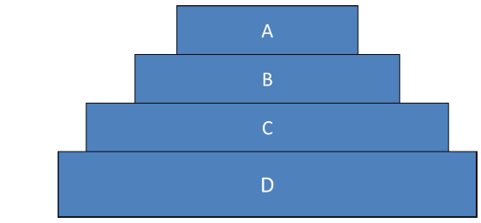

level D = producers
level C = primary consumers
level B = secondary consumers
level A = tertiary consumers.

-In all of these cases, the structured (organized) interactions of populations lead to situations in which individuals are thrown into life-or-death struggles (combat, tā-nã-zoå).
-In general, ecologists believe that a community that has a high diversity is more complex and stable than a community that has a low diversity.
-This theory is founded on the observation that the food webs of communities of high diversity are more interconnected
-Greater interconnectivity causes these systems to be more resilient to disturbance.
-If a species is removed, those species that relied on it for food have the option to switch to many other species that occupy a similar role in that ecosystem. In a low diversity ecosystem, possible substitutes for food may be non-existent or limited in abundance. For example, in the food web presented below, hawks would have many alternates than the others.

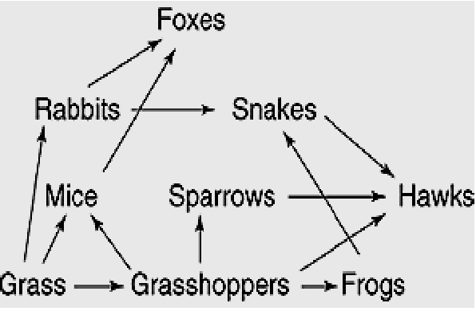
Hawk: base, ghoshawk, falcon

Session 5
Ecosystems
-Ecosystems are dynamic entities composed of the biological community and the abiotic environment.
-An ecosystem's abiotic and biotic composition and structure is determined by the state of a number of interrelated environmental factors
-nutrient availability,
-temperature,
-light intensity,
-grazing intensity,
-fire
-population density.

• Changes in any of these factors will result in dynamic changes to the nature of these systems.
-For example, a fire in the temperate deciduous forest completely changes the structure of that system:
-it destroys large trees,
-most of the mosses, herbs, and shrubs that occupy the forest floor are also destroyed, and
-the nutrients that were stored in the biomass are quickly released into the soil, atmosphere and hydrologic system.
-After a short time of recovery, the community that was once large mature trees now becomes a community of grasses, herbaceous species, and tree seedlings.

