Session 5
Chapter 2
2. Energy Flow and Nutrient Recycling in Ecosystems
Introduction
-Energy “flows” through the ecosystem in the form of carbon-carbon bonds.
When respiration occurs, the carbon-carbon bonds are broken and the carbon is combining with oxygen to form carbon dioxide.
-The breakdown of the carbon bond releases energy, which is either used by the organisms (to move the molecules, digest its food, excrete wastes, think, etc.) or the energy may be lost as heat.
-All the energy in ecosystem comes from the sun, and that the ultimate fate of all energy in ecosystem is to be lost as heat.
-Energy does not recycle; it flows.
In terms of nutrients, the autotrophs obtain the inorganic nutrients (phosphorus, Sulphur, etc.) from the inorganic nutrient pools, which is usually the soil or water. These inorganic nutrients flow from organism to organism, (as an organism eats another organism). e.g., Soil/water---plants---animals (e.g., grasshoppers).
-Ultimately, all organisms die and become detritus (tiny, teeny; ri-zəh), food for the decomposers.
-At this stage of the ecosystem, the last energy is extracted (and lost as heat) and the inorganic nutrients are return to the soil or water to be used up (consumed) again.
-The inorganic nutrients are recycled, but the energy is not recycled.

2.1. What is Ecosystem?
Brainstorming (How do you define an ecosystem?). Brainstorming: ideation (əi-dəh-pār-dã-zy).

• An ecosystem is a more or less independent part of the biosphere, for instance it includes forest, lake, river, grassland, and an ocean.
-Ecosystem has conveniently (easily) divided into two parts, which are 1) the place (habitat) and 2) the living things (community).
-It is difficult to think of one without the other: e.g., an oak forest is an ecosystem, but if you take away the community of animals and plants, there would be no oak trees, so the habitats would not be the same.
-A habitat is a place in which you find living things (animals and plants).
-The kinds of animals and plant that can live in a habitat obviously depend upon what the habitat is looks like.
Is it very hot or cold?
Is it very wet or dry?
Is the soil very acid or alkaline?
These are the climatic and edaphic factors.
-It also depends upon what other animals and plants live there (biotic factors).
For example, large trees like oak trees may provide shelter for animals against extremes of climate, but they could also prevent some plants from getting enough light for photosynthesis.
-Different animals and plants will affect each other by competition, predation, grazing, sheltering (refuging; pā-nãh dã-dān) and so on.
• Therefore, the concept of ecosystem is interactions of organisms with each other. On the water or terrestrial, organisms are depending on food; birds’ prey on fish and from some other communities.
-In other words, the basic central idea in ecosystem is the functioning that synthesis (combination and compilation) energy and the cycling of materials, i.e., organic materials are form due to photosynthesis-transfer in the form of energy from one group to the other.
-Synthesis began when plants began to build up organic material (photosynthesis). The whole ecosystem concept lies on energy is bound and energy is released.

Explain briefly the central concept of ecosystem?

Session 6
2.2. The structure of ecosystem
Brainstorming (What is the structure of an ecosystem?)

• The type of organisms found in a particular ecosystem and the pattern of interrelationships among organisms make the structure of the ecosystem. the way in which two or more things are related to each other
-It has two components:
1- biotic and
2- abiotic.
• Abiotic components include; -energy, -water, -chemicals in the soil, -climate etc.
• Biotic involves three categories
1-producers are those plants which synthesis organic materials
2-consumers are herbivores, carnivores and omnivores (animals that eat a variety of food of both plant and animal origin)
3-Decomposers are also consumers but they consume on dead and decayed materials;
-They break down the bonds of the material and release nutrients, which is the most essential part of the ecosystem.
-There are certain bacteria, which produce organic materials, are known as chemosynthetic bacteria. Chemosynthesis is the biological conversion of carbon-containing molecules into organic matter using the oxidation of inorganic compounds or ferrous ions as a source of energy, instead of sunlight.
-Generally, interacting species have a tremendous (huge) influence on the size of each other's populations. Biotic factors also regulate the size of populations more intensely.

-Finally, the influence of biotic interactions can occur at two different levels.
1-Inter-specific effects are conduct interactions between species, and
2-the intra-specific effects represent interactions of individuals within a single species.

Neutralism
Neutralism is the most common type of inter-specific interaction. Neither (none of) population directly affects the other.
• An example of neutralism would be the interaction between rainbow trout (fish; ghə-zəl-ã-lã) and dandelions living in a mountain valley.

Competition
• Competition: occurs when two different species or organisms living in the same environment (habitat) utilize the same limited resources, such as food, water, space, light, oxygen, and minerals.
If the competition is among members of the same species, it is called intra-specific. Competition among individuals of different species, it is referred to as inter-specific competition.
• Individuals in populations experience both types of competition to a greater or lesser degree.
-Competition may be the result of two different processes:
1-exploitation or
2-interference.

• Competition by exploitation
The exclusion of one organism by another. If two different species compete for the same food source or reproductive sites, one species may be eliminated. This establishes one species per niche
in a community—it is called competitive exclusion Principle←

•→Competition by interference occurs when an individual directly prevents the physical establishment of another individual in a portion of a habitat.
Example, established plants can preempt (i; ə; monopolize) the invasion and colonization of other individuals by way of dense root mats, peat and litter accumulation, and mechanical abrasion.

Amensalism 25 of 151
• Amensalism is an interaction between individuals of two different species in which one is inhibited or destroyed and the other is unaffected. One particular form of amensalism is allelopathy which occurs with plants.
-Allelopathy involves the production and release of chemical substances by one species that inhibit the growth of another. Allelopathic substances range from acids to bases to simple organic compounds. All of these substances are known under the general term: secondary substances.
-Secondary substances are chemicals produced by plants that seem to have no direct use in metabolism. A good example of a secondary substance is the antibiotic juglone which is secreted by Black Walnut (Juglans nigra) trees.
-This substance is known to inhibit the growth of trees, shrubs, grasses, and herbs found growing near Black Walnut trees. In the chaparral vegetation of California, certain species of shrubs, notably (especially) Salvia leucophylla (mint) and Artemisia californica (sagebrush) are known to produce allelopathic substances. Often these chemicals accumulate in the soil during the dry season reducing the germination and growth of grasses and herbs in an area up to 1 to 2 meters from the secreting plants.
Chaparral is a vegetation community generally composed of hard stemmed, leathery leaved shrubs. Cacti may also be present.

Mutualism
• Mutualism is the name given to associations between pairs of species that bring (cause) mutual benefit.
-The individuals in the populations of each mutualism species grow, survive and reproduce at a higher rate when in the presence of individuals of the other species.
-For example, most rooting plants have mutuality associations with fungal mycorrhizae. Mycorrhizae increase the capability of plant roots to absorb nutrients like nitrogen and phosphorus. In return (instead), the roots of the host provide a constant supply of carbohydrates for consumption.
-Mutuality interactions between species can be of two types:
1. symbiotic or
2. non-symbiotic.
In a symbiotic mutualism, individuals interact physically and their relationship is biologically essential for survival. At least one member of the pair cannot live without close contact with the other.
-For example, the fungal-algal symbiosis that occurs in lichens (ãÎ; k). The morphological structure of a lichen is a mass of fungal hyphae that forms around a small colony of algae cells. (ji)
-In this mutualism, the alga produces carbohydrates and other food by products through photosynthesis and metabolism, while the fungus absorbs the required minerals and water to allow for these processes to occur.

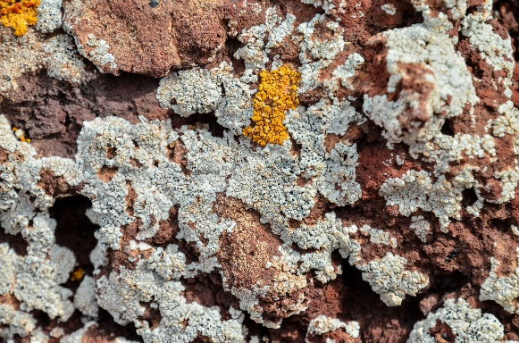
Algae

• More common in nature is the non-symbiotic mutualism.
In this interaction, the mutualisms live← independent lives yet (but) cannot survive without each other.
Example of an interaction of this type is the relationship between flowering plants and their insect pollinators.
In this interaction, the flower becomes pollinated by the insect, while the bee receives food in the form of pollen and nectar.

Session 7
Predation, Parasitism, and Pathogens
• Pathogens, parasites, and predators obtain food at the expense of their hosts and prey.
Predators tend to be larger than their prey and consume them from the outside.
-A parasite or pathogen is smaller than its host and consumes it either from the inside or from the outside of the organism. It is easy to believe that the predator-prey interaction is somehow detrimental (harmful) to the prey population.
-The population sizes of predator and prey species are inter-regulated by delicate feedback mechanisms that control the densities of both species. Sometimes predator species can drive their prey into localized extinction (demolition, destruction).
In complex communities, this does not have particular harm to the predator if several other species exist as alternative prey.

List down the components of the structure of ecosystem?

Forms of energy
• Nuclear energy (from uranium)
• Geothermal energy (from inside of the earth)
• Solar energy (from the sun)
• Fuel energy (from petroleum, coal and natural gas)
• Chemical energy (from food) Sources of energy
• Fossil fuels (petroleum, coal, natural gas)
• Alternative energy sources (solar, nuclear, geothermal)

2.3. Energy Flow in Ecosystem
Brainstorming How energy flows in an ecosystem?

• The flow of energy through life is not an endless cycle. Energy flows from the sun to the plants to the plant eaters to the meat eaters.
-As energy moves up the food chain there is less and less amount of energy transfer to the higher levels along the food chain.

Activity
Describe what happens to the solar energy that reaches the earth from the sun?
Most of the solar energy that falls on the earth is not used by plants. It bounces back to space or heats the air, oceans, and ground, and makes weather, among other things.

• Little bit of the solar energy that hits the earth is used by plants. The herbivores only get a little bit of the energy that hits the plants. The carnivores and decomposers only get a little bit of the energy that was eaten by the herbivores.
-Most of the plant energy that is consumed by herbivores is used to keep themselves, such as eating, breathing, walking, and staying warm. Only a little bit is left over for the carnivore or decomposer that eats the herbivore.
What would happen if the sun stops generating energy?

• We need fresh sunshine every day and new plants have to keep growing. Otherwise, the whole amazing system would quickly run out of energy and everything alive would come to a "dead" stop.

The flow of energy level
• The pathways of energy through the living components of an ecosystem are represented by food chains and food webs.

1) Primary Producers:
• Green plants and certain types of bacteria and algae are the primary producers because they are the ones that produce usable energy for the rest of the living organisms on earth.

2) Herbivores
• Herbivores are the plant eaters. They have the ability to digest the plants they eat and release the energy stored in the plant cells for their own use. Some examples of animals in this group are deer, cows, elephants, rabbits, elks, zebras, most insects, and birds that eat fruit and seeds. Sometimes scientists call this level of the food chain the primary consumers (sounds like economics class).

3) Carnivores
• These guys are the meat eaters. Predators and scavengers are in this group. Sometimes this level in the food chain is referred to as the secondary consumers. They eat the guys that eat the plants and sometimes they eat each other. Most of these animals can't eat plants at all.
-They have got the glamour (fascination; fā-ri-bān-də-gy) job but they are really pretty helpless (unable to defend themselves) without all the plants and herbivores. Cats and dogs, killer whales, sharks, spiders, snakes, wolves, vultures (lãsh-khor), hawks, eagles, crocodiles are in this group.

4) Decomposers - are the opposite of composers.
• They are the creatures that eat up dead bodies - both plant and animal. This group of useful critters (creatures) is mostly bacteria and fungus. Without them there would be a lot of dead bodies lying around.
-They're like carnivores and herbivores, because they also have to get their energy from the cells of animals or plants. The difference is they prefer their food dead - very dead.
-The stages of food transfer at each stage are called trophic level. At each stage of food transfer the chain or web potential energy is lost through digestion of organic material resulting to a continual diminishing of available energy. 35
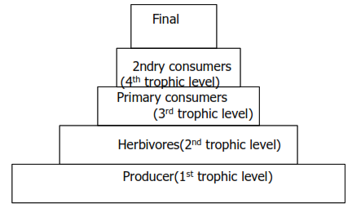
Fig. Normal Pyramid Number

• Pyramid number shows the decline of energy at every successive stage. This is called normal pyramid number. The pyramid of biomass tells as how much kilograms of energy stored on the primary organisms. The amount of energy stored in the bottom is greater than that of the top which shows the second law of energy. The amount of energy decreases from the bottom to top.
-In the pyramid of energy, we measure is the amount of energy transferred between trophic levels or it measures the amount of energy utilized by different organisms over a sample area per a set of area example 1 meter square per one year.

Explain in detail phrases such as trophic level, pyramid of biomass and pyramid of energy?

Session 8
2.4. Biogeochemical Cycle
• We have already seen that while energy does not recycle through an ecosystem, chemicals do. Since the inorganic chemicals get recycled through both the biological and the geological world, we call the overall cycle’s biogeochemical cycles.
-Each chemical has its own unique cycle, but all of the cycles do have something in common. Reservoirs are those parts of the cycle where the chemical is held in large quantities for long periods of time. In exchange pools the chemical is held for only short time.
-The length of time a chemical is held in an exchange pool or a reservoir is termed its residence time. The oceans are a reservoir for water, while a cloud is an exchange pool.
-Water may reside in an ocean for thousands of years, but in a cloud for a few days only. The biotic community includes all living organisms. This community may serve as an exchange pool and also serve to move chemicals from one stage of the cycle to another.
-For instance, the tree of the tropical rain forest brings water up from the forest floor to be evaporated into the atmosphere. The energy for most of the transportation of the chemicals from one place to another is provided either by the sun or by the heat released from the mantle and core of the Earth. While all inorganic nutrients have cycle, we will focus only on five of the most important cycles, i.e., water, carbon, oxygen, nitrogen and phosphorus.

The Water Cycle
Water Cycle involves the processes of photosynthesis, transpiration, evaporation and condensation, respiration, and excretion
-The various earths’ water-sources get their supplies from precipitation, while the precipitation in itself is evaporation from these sources.
Water is lost to the atmosphere as vapor from the earth, which is then precipitated back in the form of rain, snow, hail, sleet (boo-ran) or frost, etc. This precipitation and evaporation continue forever, and thereby a balance is maintained between the two. This process is known as hydrologic cycle and shown in figure.
(a deposit of small white ice crystals formed on the ground or other surfaces when the temperature falls below freezing, شبنم یخ زده)
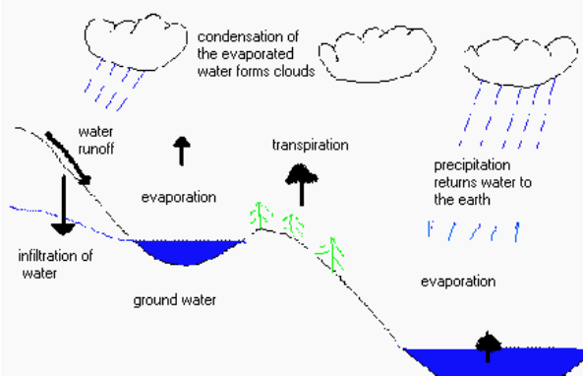
Figure page 39

The Carbon Cycle
• All life is based on the element carbon. Carbon is the major chemical constituent of most organic matter, from fossil fuels to the complex molecules (DNA and RNA) that control genetic reproduction in organisms.
The RNA (Ribonucleic acid) directs two processes—protein synthesis and replication (the process by which RNA copies itself). In cellular organisms, another type of genetic material, called deoxyribonucleic acid (DNA), carries the information that determines protein structure. But DNA cannot act alone and relies upon RNA to transfer this crucial information during protein synthesis.

• Yet (however) by weight, carbon is not one of the most abundant elements within the Earth’s crust. In fact, the lithosphere is only 0.032 % carbon by weight. The concentration of carbon in living matter (18%) is almost 100 times greater than its concentration in the earth (0.19%), i.e., living things extract carbon from their nonliving environment.
-For life to continue, this carbon must be recycled. From biological point of view, the key events in the carbon cycle are the complimentary reactions of respiration and photosynthesis.
-During respiration taking place carbon dioxide and water produces. The outputs of respiration are inputs of photosynthesis, and the outputs of photosynthesis are the inputs of respiration.

-These reactions are also complimentary in the way they deal with (sā-ro kãr dãsh-tān bã) energy.
• Photosynthesis takes energy from sun and stores it in carbon-carbon bonds of carbohydrates whereas respiration releases that energy. Both plants and animals carry on respirations, but only plants can carry on (continue) photosynthesis. 40
•The chief (main, major) reservoirs for carbon dioxides are in the oceans and in rock. Carbon dioxide dissolves readily in water.
-Once there, it may precipitate as a solid rock known as calcium carbonate (limestone). Corals and algae encourage this reaction and build up limestone reefs in the process. On land and in the water, plants take up carbon dioxide and convert it into carbohydrates through photosynthesis.
-This carbon in the plants now has three possible fates.
1. It can be liberated (release) to the atmosphere by the plant through respiration;
2. it can be eaten by an animal, or
3. it can be present in the plant when the plant dies.

•Animals obtain all their carbon through their food, and thus, all carbon in biological systems ultimately comes from plants (autotrophs). In the animal, the carbon also has the same three possible fates.
Carbon from plants or animals that is released to the atmosphere through respiration will either be
1-taken up by a plant in photosynthesis or
2-dissolved in the ocean.

-When an animal or plant dies, two things can happen to the carbon in it.
1-it can either be respired by decomposers, or
2- it can be buried intact and ultimately form coal, oil, or natural gas.

-The fossil fuels can be mined and burned in the future; releasing carbon dioxide into the atmosphere. Otherwise, the carbon in the limestone or other sediments can only be released to the atmosphere when
1-they are subducted (fo-roo-rãn-dān) and brought to volcanoes, or
2-pushed to the surface and slowly weathered away.
What will be the impact of humans on the carbon cycle? End of page 41

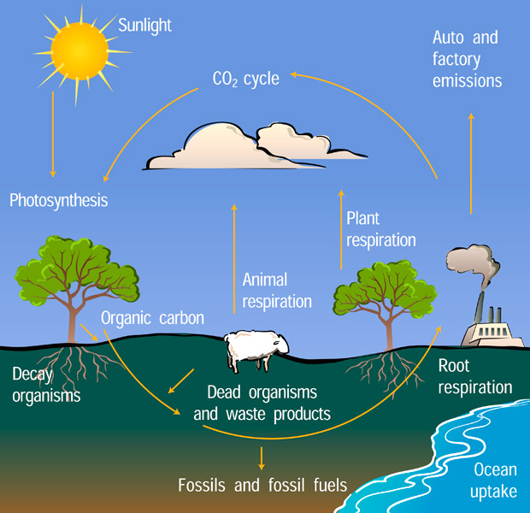

What will be the impact of humans on the carbon cycle?
Humans have a great impact on the carbon cycle because when we burn fossil fuels more carbon dioxide goes into the oceans, and more is present in the atmosphere.
-The latter condition causes global warming, because this carbon dioxide in the atmosphere allows more energy to reach the Earth from the sun than it allows escaping from the Earth into space.

Session 9
The Oxygen Cycle
-The carbon cycle covers the oxygen cycle also because these atoms are often combined. Oxygen is present in the carbon dioxide, carbohydrates and water. Oxygen is released to the atmosphere by autotrophy during photosynthesis and takes up by both autotrophs and heterotrophs during respiration.
-All the oxygen in the atmosphere is biogenic, i.e., it was released from water through photosynthesis by autotrophs. It took about two billion years for autotrophs (mostly cyanobacteria) to raise (to increase) the oxygen content of the atmosphere to the current 21 %. This opened the door for complex organisms such as multi-cellular animals, which need a lot of oxygen. This in turn enabled the evolution of complex organisms such as animals and human beings.

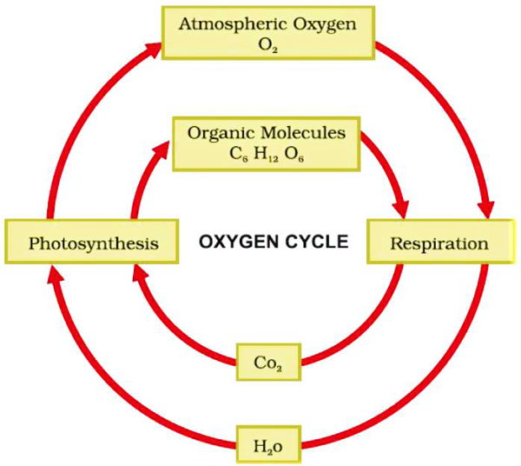

The Nitrogen Cycle
It is another most important nutrient cycle found in terrestrial ecosystems. Nitrogen is used by living organisms to produce a number of complex organic molecules like amino acids, proteins, and nucleic acids. Major stores of nitrogen;
1-atmosphere (largest reservoir) --it exists as a gas (mainly N₂)
This storage is about one million times larger than the total nitrogen contained in living organisms.
2- It also stores as organic matter in the soil and the oceans.

-Despite its abundance in the atmosphere, nitrogen is often the most limiting nutrient for plant growth.

The nature of nitrogen cycle
-The nitrogen cycle is one of the most difficult of the cycles to learn, simply (just) because there are so many important forms of nitrogen, and because organisms are responsible for each of the inter-conversions.
-It takes a lot of energy to get nitrogen gas to break up (separate) and combine with other things, such as oxygen.

Session 10
Nitrogen fixation
• Nitrogen gas can be taken from the atmosphere in two basic ways.
1. First, lightning provides enough energy to “burn” the nitrogen and fix it in the form of nitrate (NO₃) which is nitrogen. This process is duplicated in fertilizer factories to produce nitrogen fertilizers.
2-The other form of nitrogen fixation is by nitrogen fixing bacteria, which use special enzymes instead of the extreme amount of energy in lightning to fix nitrogen.
-What are these nitrogen fixing bacteria?
These nitrogen fixing bacteria come into three forms:
1-some are free living in the soil;
2-some form symbiotic, mutualistic associations with the roots of bean plants and other legumes (rhizobia bacteria); and
3-photosynthetic cyanobacteria (blue green algae) which are found most commonly in water.
All of this fix nitrogen, either in the form of nitrate (NO₃) or in the form of ammonia (NH₃).
Most plants can take up nitrate and convert it into amino acids.

How do animals acquire amino acids?
Animals acquire all of their amino acids when they eat plants or other animals.
-When plants or animals die or release waste the nitrogen is returned to the soil. What is that waste called? (zã-yə-ãt)
-The usual form of nitrogen returned to the soil in animal wastes or in the output of the decomposers, is ammonia (NH₃).
• Ammonia is rather toxic, but there are nitrite bacteria in the soil and in the water which take up ammonia and convert it to nitrite (NO₂-). However, nitrite is also toxic, but another type of bacteria, the nitrate bacteria, takes nitrite and converts it to nitrate (NO₃), which can be taken up by plants to continue the cycle.

Short summary of nitrogen cycle
• Nitrates (used by plants)
• Build plant proteins
• Eaten by animals
• made into animal proteins
• Plants and animals die
• bacteria decay
• Ammonia (NH3)
• Nitrifying Bacteria
• Nitrates (used by plants)

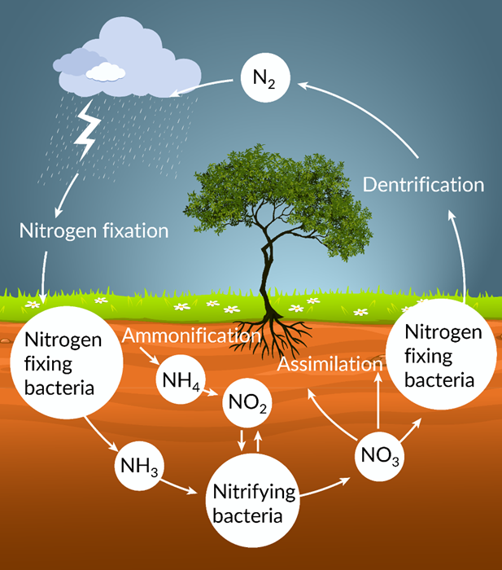

Phosphorus Cycle
In nature, phosphorus in the form of phosphate is present in rocks.
When rock with phosphate is exposed to water (especially water with a little acid in it), the rock is weathered out and goes into solution.
-Autotrophs take this phosphorus up and use it in a variety of ways. It is an important constituent of cell membranes, DNA, RNA and ATP.
-Heterotrophs (animals) obtain their phosphorus from the plants they eat. However, one type of heterotrophy, the fungi, excel (having superiority) at taking up phosphorus and may form mutualistic, symbiotic relationships with plant roots.
-These relationships are called mycorrhizae; plants get phosphate from the fungus and give the fungus sugar in return. Animals may also use phosphorus as components of bones, teeth and shells.
When animals or plants die, the phosphate will be returned to the soil or water by the decomposers. There, it can be taken up by another plant and used it again.

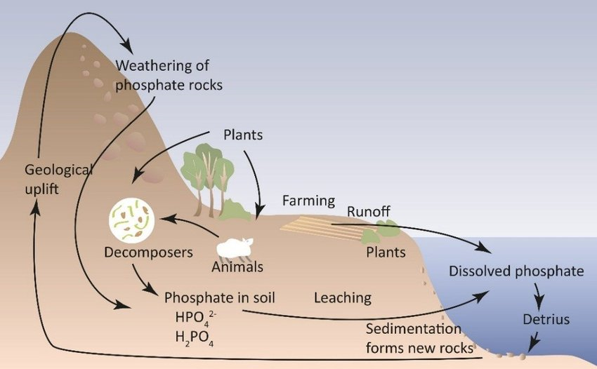
Two types of animals play in the cycle of phosphorus.
1-Humans
Humans often mine (exploitation, extraction) rock rich in phosphorus; the phosphate is then used as fertilizer. This mining of phosphate and use of the phosphate as fertilizer greatly accelerates the phosphorus cycle and may cause local overabundance of phosphorus particularly in coastal regions, at the mouth of rivers, and any place where there is a lot of sewage released into the water.

2-The other animal that plays a unique role in the phosphorus cycle are marine birds.
• The birds take phosphorus containing fish out of the ocean and return to land, where defecate (shit), their guano contains high levels of phosphorus and in this way marine birds return phosphorus from the ocean to the land. the excrement of seabirds and bats, used as fertilizer
Define biogeochemical cycle? Elaborate (in detailed) the process of carbon cycle, water cycle, nitrogen cycle, phosphorus cycle and oxygen cycle?

Summary
Ecosystems
Ecosystems are conveniently divided into two parts which are the place (habitat) and the living things (community).

A habitat is a place in which you find animals and plants. The kinds of animals and plants which can live in a habitat obviously depend upon what the habitat is looks like. The community consists of all the animals and plants living in one habitat. Different animals and plants will affect each other by competition, predation, grazing, sheltering and so on. The concept of ecosystem is interactions of organisms in the biophysical environment, i.e. the functioning in synthesis of energy and the cycling of materials.

Structure of the ecosystem
A type of organisms found in a particular ecosystem and the pattern of inter relationships among organisms make the structure of the ecosystem. It has two components: Biotic: producers, decomposers and consumers Abiotic: water, chemicals in the soil.

Flow of energy
The flow of energy through life is not an endless cycle. The energy doesn't go round and round getting used over and over again and never wearing out. As energy moves up the food chain there is less and less amount of energy transfer to the higher animals along the food chain. In the pyramid of energy, we measure the amount of energy transferred between trophic levels.

Biogeochemical cycle Biogeochemical cycle is the processes whereby in the ecosystem the biotic and abiotic environmental factors and their interaction between them are taking place.
Carbon dioxide is used by plants in photosynthesis to make carbohydrates. When animals eat plants, these carbohydrates are turned into animal carbohydrates e.g. glycogen. Eventually all animals and plants die and when bacteria or fungi decompose them, the carbon are returned to the atmosphere as carbon dioxide. Nitrogen is also recycled by nature. Plants use nitrates from the soil to make proteins. Animals get their proteins by eating plants. Dead animals and plants release ammonia when they are decomposed. Nitrifying bacteria in the soil convert ammonium ions into Nitrate ions so completing the cycle.

Chapter Three 3.
Living organisms and the environment page 52

