Illustrative example
As mentioned in the contribution part of ''Paper TSG-00676-2019.R1 by Dr. Maryam A.Hejazi, A Unified Approach For Reliability Assessment of Critical Infrastructure Systems Based on Graph Theory and Entropy'', one of the main goals of this research is presenting a unified performance measure for the CIS reliability assessment which based on its different reliability indices can be calculated. Based on the descriptions about entropy which has been presented in the paper, this unified performance measure can be expressed as follows:
For a CIS, different levels of entropy and changes in these levels can be obtained and monitored for the whole of the system as a system performance measure.
There are two points which should be considered for this claim. 1) Why the entropy of the system can be considered as a performance measure for the system, and 2) how could calculate the entropy of the system not only from failure probability of the elements and whole of the system but also from different reliability indices of the system?
In the following these points have been addressed.
Why the entropy of the system can be considered as a performance measure for the system?
Suppose that system is operated in region A of Fig. 1 and a shock affected system performance.
Figure. 1: Reliability and entropy distance relation
In this situation damages increase failure probability of the system which causes that entropy of system increased. The absorptive capability of the system absorbs the negative impacts caused by disruptive events which cause the entropy of the system to increase up to a specified level. The adaptive capability of the system causes that entropy curve experiences a maximum point. Afterward, the restorative capability of the system based on the different actions recovers the system from this situation and causes that failure probability of system reduced which causes that entropy of system reduced. Based on these descriptions entropy curve of the system can be used as a performance measure of the system. Different security concepts such as reliability, resilience, and robustness can be obtained from this performance measure which in this paper only reliability concept has been introduced.
How could calculate the entropy of the system as a performance measure for the system?
System performance can be considered from network performance to network connectivity assessment. If network connectivity is considered, entropy of the system will be calculated based on the failure probability of elements and the whole of the system based on the (13), (14), (15) and (16) which this procedure has been presented in page 6 of the paper.
If network performance is considered, the entropy of the system will be calculated based on the different indices which are used in the security assessments. For example, the number of available transmission lines (topology related) or actual power demand served for the whole of the system (functionality related) are two examples in which the performance of the system can be calculated based on them [1]. For this goal, after defining safe or failure probabilities definitions in each cut set or whole of the system from these indices point of the view, the entropy of each cut set and the whole of the system will be calculated as different performance measures for system. Different indices and performance measures can be defined based on the purpose of the study which in the following more explains about them is expressed.
Redefined reliability indices based on the graph entropy method
There are some widely used indices in reliability evaluation of CIS, including load indices and system indices [2]. Load indices evaluate system performance from load point of the view; like LOLP (Loss of Load Probability) and LOLE (Loss of Load expectation). System indices evaluate system performance from the whole of the system point of the view. In this paper, focus is only on network connectivity and in our next publication network performance and load indices will be discussed. As mentioned in the paper in the page 7, line 17, system network reliability indices range from the network performance to network connectivity reliability indices. Examples of network performance reliability indices include Average Service Availability Index (ASAI), System Average Interruption Frequency Index (SAIFI) and examples of network connectivity reliability such as two-terminal connectivity, K-terminal connectivity, and all-terminal connectivity reliability have been presented in the paper.
For redefinition of these indices based on the graph entropy method, performance measure of the system based on each of these indices should be calculated in the first step and then by use of the new definition of reliability by use of the Kullback-Leibler concept which introduced in the paper in (18), each index will be calculated. Network connectivity reliability index has been redefined and calculated in the section IV of the paper. Based on the requisition of the respected editor and reviewers, for comparison with the existing indices, a network performance reliability index has been redefined based on the proposed method. Different indices can be redefined like this index.
In continue, ASAI index as a network performance reliability index has been redefined based on the proposed method. Before presenting this redefined index, there is a point about choosing ASAI index for CIS reliability studies. As mentioned in the contribution part, one of the goals of this research is presenting unified reliability indices for all CIS subsystems without relation to the nature of each subsystem; because the goal is the reliability assessment of a CIS (for example gas- power- cyber system) simultaneously. ASAI index has been selected because nature of it can be extended to different subsystems of CIS. Now in the following this index has been redefined based on the proposed method.
As mentioned in the previous section for calculating different indices by use of the new proposed method, in the first step, performance measure of the system by desired indices should be calculated. For calculating ASAI, in first step performance measure of the system from the available service point of the view should be calculated. The numbers of available transmission lines in the power system or the number of Remote Terminal Units (RTU) in the cyber system are two examples that can be considered for ASAI index. For calculating performance measure, the following definitions have been presented [1]:
Probability of transmission lines availability in power system:
(1)
And
Probability of remote terminal unit's availability in cyber system
(2)
After this, the entropy of each cut set and the whole of the system will be calculated as the performance measure of the system. There is a point for calculating the entropy of the system in this situation. Because these indices are considered for the whole of the system, system entropy of them can be calculated based on the number of available and total elements in the whole of the system, instead of each cut set. In fact, the entropy of the system can be calculated in the whole of the system directly. So that entropy of the system (performance measure of system) for power (E_{s,power}) and cyber (E_{s,cyber}) systems are defined as:
(3)
And
(4)
After calculating performance measure for different states of the system, reliability of system can be calculated in each state like steps 8 and 9 for network connectivity reliability assessment which introduced in previous part. In order to compare these reliability indices with competing solutions, performability metric should be calculated. The Average Substation Service Availability Index (ASSAI) is the ratio of the total number of hours that service is provided by all available substations to the total demanded hours [1]:
(5)
ASSAI (Average Substation Service Availability Index) and ASAI (Average Service Availability Index) indices have same concept because both of them are related to the availability of service in a specified period. Where Res_{i} represents the restoration time for the i-th substation if service interruption exists and N_{S} represents the total number of substations. As seen in (5), this index is calculated in specified duration time. So that for the correct comparison between (5) and new proposed reliability index, this newly introduced index should be calculated in a specified duration. So that, average of distance between entropy of system in each state, E_{s}, and E₀ (D(E_{S} ,E₀)), for all of the states which system experiences in a specified duration, should be calculated and then, probability that these average distance D_{average}(E_{S} ,E₀) approaches to 0, considered as new ASSAI index which re-defined based on the new proposed method on this research. Suppose that system is operated in region A and a shock affected system performance at the time t_{d}. As mentioned, absorptive, adaptive and recovery capabilities of system cause that, first system entropy increase and then decrease. At the time t_{s}, system reaches a new stable state. The curve of entropy among these changes has been shown in Fig. 2, as a function of time. As shown in the Fig. 2, D (E_{S} ,E₀) for different states of the system can be calculated. If N_{t} be the number of states that system experience between t_{d} and t_{s} and D_{i} be the distance between entropy of system in i-th state, E_{s,i}, and E₀, D_{average}(E_{S} ,E₀) will be calculated as follow:
(6)
Based on the proposed method, the probability that D_{average} approaches to 0 is the new re-defined ASSAI index (ASSAI_NEW) which can be calculated by Monte Carlo method as follows:
(7)
In this equation I is identity matrix, is a small number close to zero and vector X is a Bernoulli random variable with parameter P, which P is calculated from (1) and (2) in different states. Also in (7) N is the number of iteration of Monte Carlo algorithm. As D_{average}(E_{S} ,E₀) has been calculated from ASSAI performance measure of the system, (7) will be new re-defined ASSAI index based on the new proposed method in this paper.
Figure 2: entropy as performance measure of system

To illustrate the effectiveness of the proposed method two scenarios have been considered. In the first scenario network connectivity reliability assessment based on the proposed method has been presented in the section IV of the method and in the second scenario, performance reliability assessment for evaluating the ASSAI index of a real case has been presented in the following.
In this scenario the Swiss high-voltage Electric power supply system (EPSS) which is illustrated in Fig. 3, with 219 transmission lines and 129 substations is selected as an exemplary application to demonstrate the feasibility of the proposed method for performance reliability assessment of a cyber- power system (CIS); And also comparison to similar study for validation of the proposed method has been done based on this case which is presented in [1]. In this case multilevel hybrid modeling for power system with 587 component include transmission lines, generators and bus bars and cyber system with 588 component include field instrumentation and control devices (FIDs and FCDs), remote terminal units (RTUs) and master terminal unit (MTU) have been done. According to [3], the estimated frequency of natural hazards, i.e. winter storms, which have the potential of resulting in the simultaneous disconnection of 20 transmission lines is in the range of 6*10-4 – 7*10-4 per year in Switzerland. In this case, it is assumed that about 17 power transmission lines are disconnected at t= 3h, because of a natural hazard, i.e. winter storm, which affected the central region of Switzerland (highlighted in the circle of Fig. 3), where power transmission lines are located. Normal distribution N(35 s,3 s²), has been considered for interval between sudden disconnections of two lines which happened after occurrence winter storm at t=3h [1]{Nan, 2017 #4}. The sudden disconnections of transmission lines could also overload other transmission lines, especially the neighboring one, and have the potential for knock-on effects with cascading consequences. Based on the interdependences between power and cyber system, the disconnection of transmission lines of power system cause service interrupts of RTUs. An RTU component is out of power if its connected transmission lines are all disconnected and its battery is fully depleted.

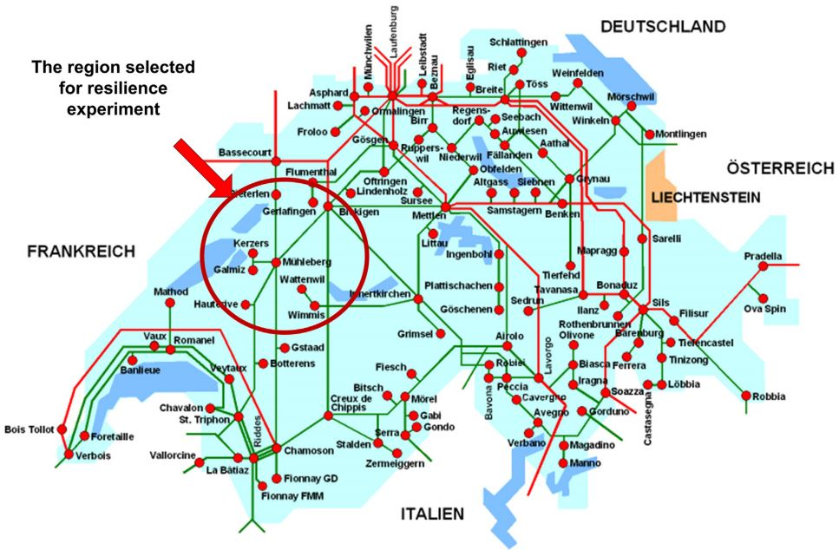
Figure 3: Swiss high-voltage Electric power supply systems

Based on these descriptions and explains in the previous section for performance reliability assessment of this cyber-power system from ASSAI index point of the view, two performance measures including E_{s,power} and E_{s,cyber} based on the P_{aL} and P_{aR} should be calculated in the first step by use of the proposed method in this research. Suppose that disruptive event at t=3h, has been triggered. The negative effects appear immediately, i.e. the P_{aL} value drops after the first line disconnection. Due to power shortage from the disconnection of transmission lines and RTU batteries consumption by considering RTU battery capacity (RBC) = 10 min, the P_{aR} value drops as well after a certain time. Both systems start recovering by considering the components mean time to repair (MTTR)= 2.5h, after reaching their lowest performance levels about 30 min for power system and 40 min for cyber system after the shuck. Repairing actions will be continued until the system reaches to the new steady state after a certain period. Variations of P_{aL} and P_{aR} for these situations have been shown in Fig. 4 [1]. Also, entropy of power and cyber systems (system performance measure of them), based on the equations (3) and (4) of the response letter have been calculated and shown in Fig. 4.

Figure 4: Probability of transmission lines and remote terminal units availability in power and cyber system
Figure 5: Performance measure of for power and cyber systems
ASSAI_NEW index for power and cyber systems- After calculating the performance measure of power and cyber systems, the ASSAI_NEW index for each of these systems has been calculated based on the (6), and (7). Results have been compared with the [1], in Table.4 which express good and acceptable accuracy of the proposed method.
Table 4: ASSAI_NEW index for power and cyber systems
 | D_{average} | ASSAI_NEW | ASSAI [1]
Power system | 1.1373e-04 | 0.973 | 0.976
Cyber system | 1.0343e-04 | 0.9797 | 0.977

ASSAI_NEW index for Cyber- Power system- Until now, ASSAI is defined for each of the cyber and power subsystems, separately. But, what is the reliability of the cyber-power (CIS) system? As mentioned in previous sections, for this goal, performance measure of the whole of the system, E_{s}, has been calculated based on the E.q (6) of the paper and results have been shown in Fig. 6. Then ASSAI_NEW index for cyber-power system has been calculated based on the (6), and (7) and result has been presented in Table. 5.

Figure 6: performance measure of whole of the system (E_{s}) and mutual information between cyber and power system as NNI (E_{mutual})
Table 5: ASSAI_NEW index for Cyber- Power system
 | ASSAI_NEW
Cyber- Power system | 0.9528

Presenting new interdependencies definitions are other achievements of this proposed method, which in continue, NNI as an example of them has been presented for this case study.
NNI calculation for cyber-power system- The cyber and power systems are dependent on each other for their operations. The cyber system is dependent upon the power system for the power supply while power system is dependent upon cyber system for the transmission of control actions and measurements. These interdependencies can be determined based on the definition of NNI, which is presented as the mutual information between cyber and power system in section III, part B. NNI has been shown in Fig. 6 as a function of time (E_{mutual}). It can be seen in Fig. 6, at hours that incorrect operation of cyber and power system affected each other, interdependency between them has been increased.

REFERENCES
[1] C. Nan and G. Sansavini, "A quantitative method for assessing resilience of interdependent infrastructures," Reliability Engineering & System Safety, vol. 157, pp. 35-53, 2017.
[2] S. M. Rinaldi, J. P. Peerenboom, and T. K. Kelly, "Identifying, understanding, and analyzing critical infrastructure interdependencies," IEEE control systems magazine, vol. 21, no. 6, pp. 11-25, 2001.
[3] M. Raschke, E. Bilis, and W. Kröger, "Vulnerability of the Swiss electric power transmission grid against natural hazards," in Conference Proceedings ICASP11, 2011, pp. 1407-1414.

